1. Database auto backup / restore

Database Need to be auto backup on localserver with Location option ( Means Path where to save the Backup)

Database Need to be auto backup on Online with OneDrive / Dropbox option.

1. Pin Login page Something Like

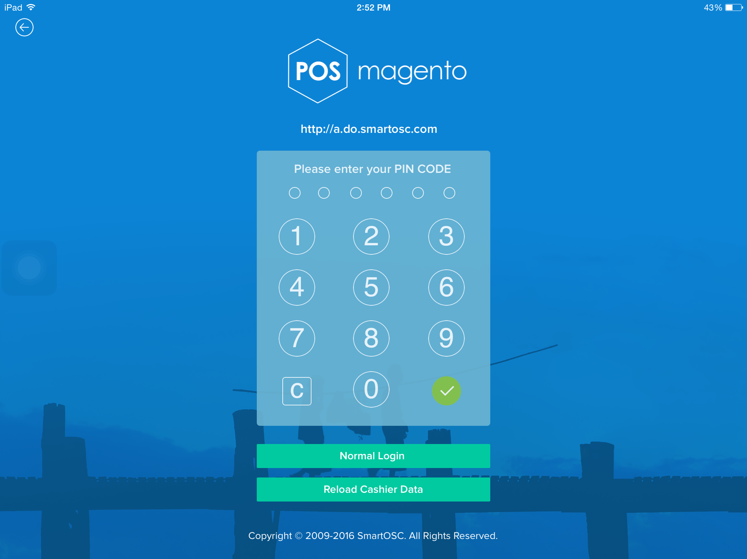

1. Don’t show 0 Inventory Products in POS sale Menu
2. Close( X) Option in opened Bill in PSO
3. Change in Print icon In Sales Change Like

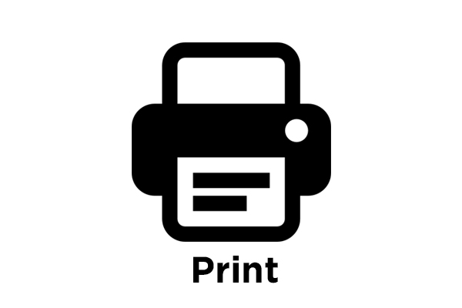

1. Show user Col. In every Report Section
2. Email Configuration option like

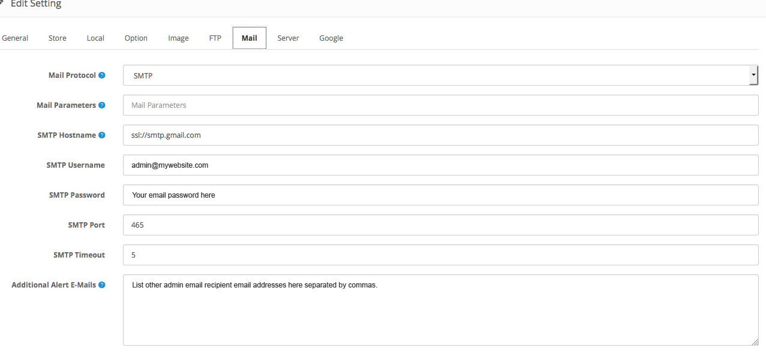

1. Show Expenses Col. In Profit and Loss reports and – Minus them with Sales to get actual Profit for the Period .